In Interview, they may ask you tell me some interfaces , classses of Selenium WebDriver

How to read Selenium webDriver from Selenium doc

How to check internal Interfaces and Classes in Selenium WebDriver API

-How to check implementation of different methods (Available in different classes, firefox Driver class, Chrome Driver class, webdriver interface)

-How to read Java Reference Doc (how to know this is normal class, abstract class, interface)

Open Seleniumhq.com -- > Go to downloads

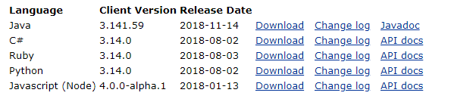

* Click on Java doc of Language Java

You will see the packages here

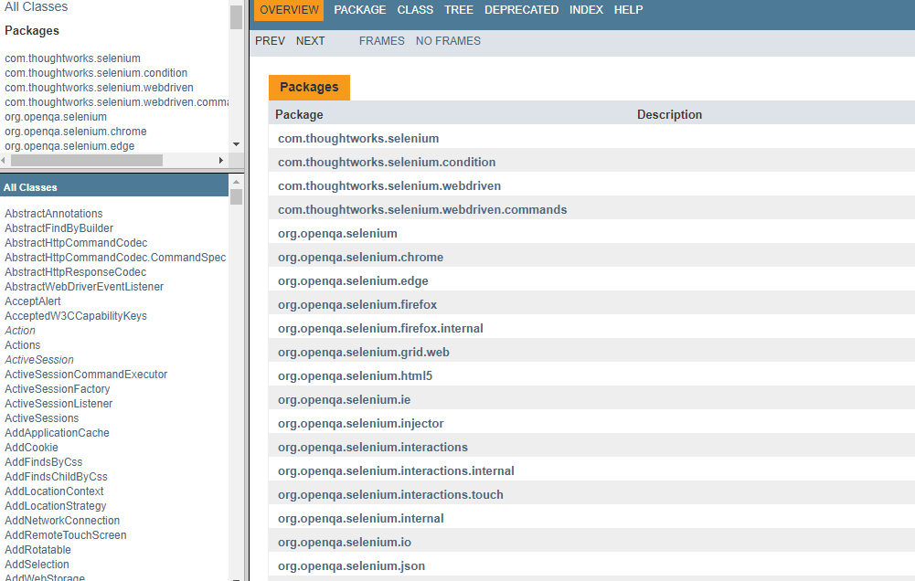

* U can find All classes in left hand side
* Click on particular package , its summary will open

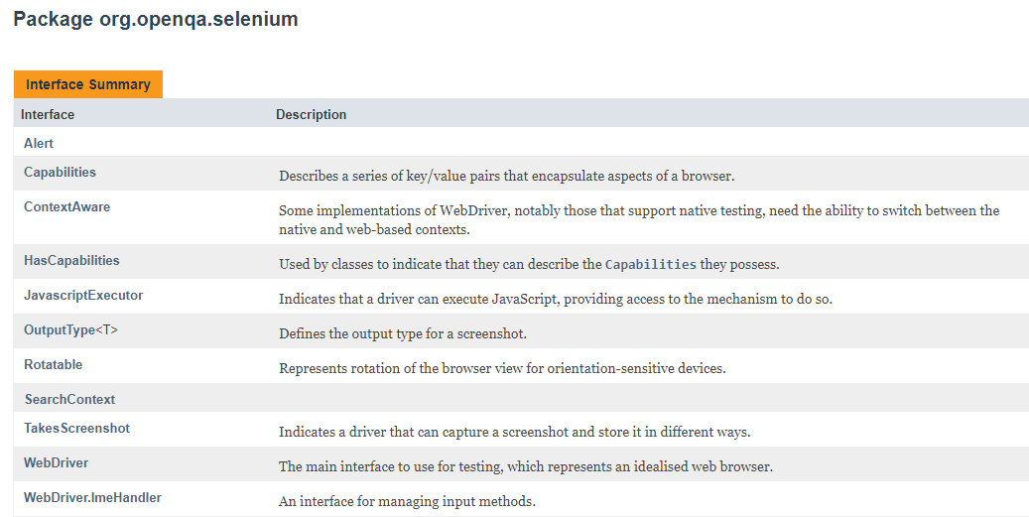

* In classes, its clearly given, when we place mouse there it will give u , it’s a class or interface
* Interfaces are written in Italic



WaitForPopup – is a class

WebDriver – is a interface

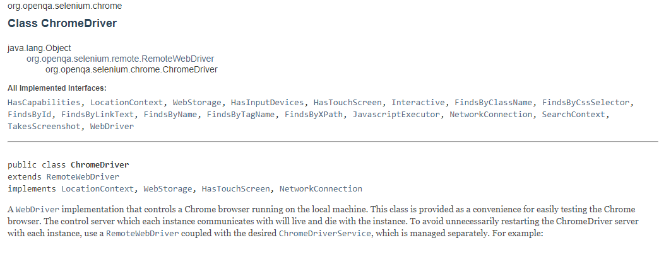



These all are interfaces only

When we are calling

1)WebDriver driver = new ChromeDriver();

Internally it is calling ChromeDriver() constructor

2)Constructor with Desired Capabilities

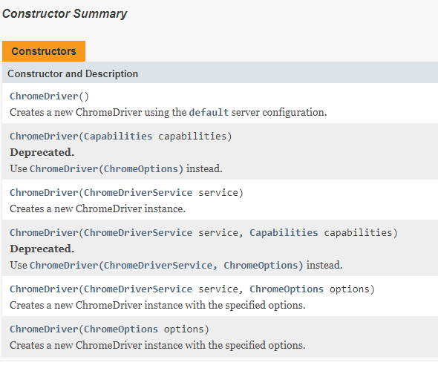

WebDriver Interface

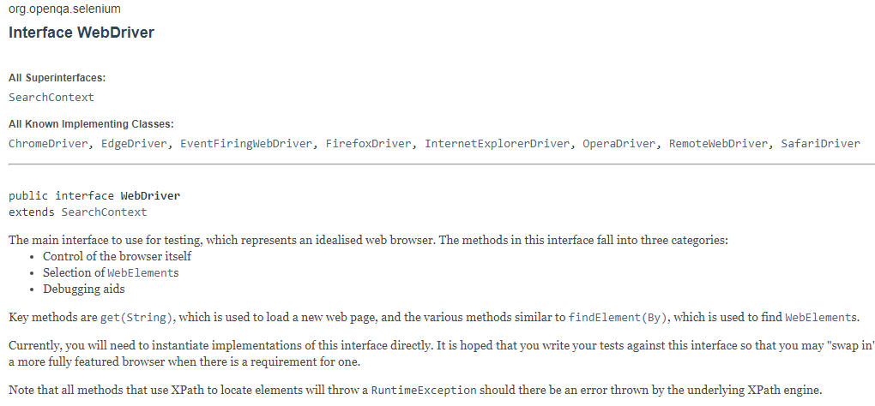

U can see All methods and its explanation when you scroll down

Eg:

1. driver.get(URL) - returns void (nothing)

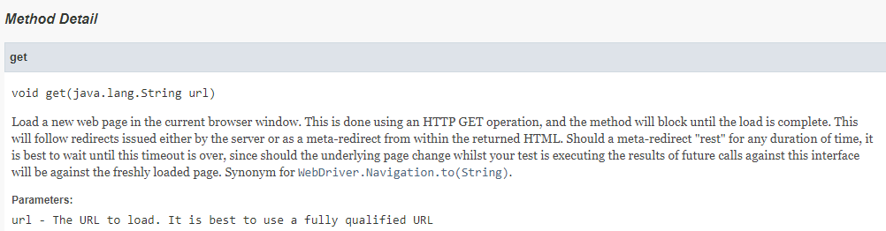

1. driver.getCurrentUrl() - returns String
2. driver.getTitle() – returns String

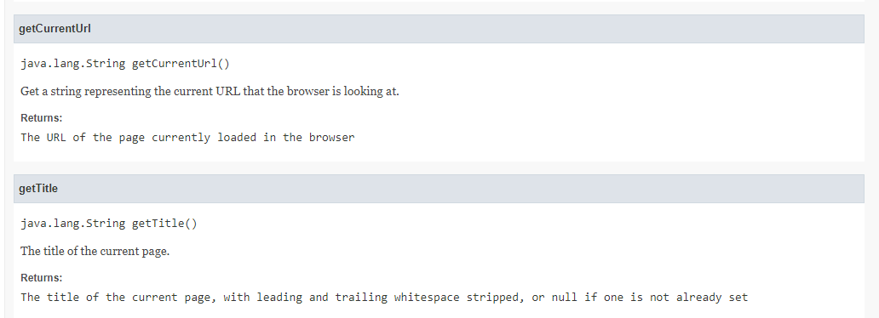

U can also see Exceptions

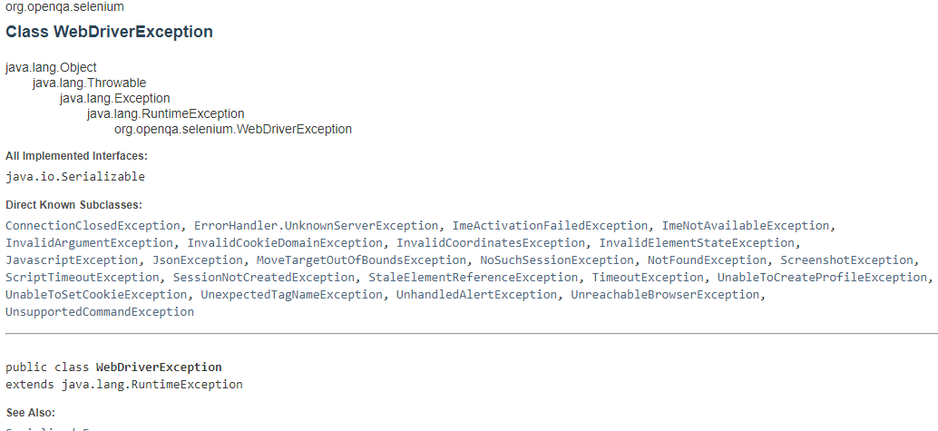

* Can see like this for all classes, interfaces

Actions, Select, FireFox Driver

* For Every thing u can see Documentation there, which is Javadoc of selenium Webdriver
* U can also have to provide documentation like this, to the customer if you want to give